**Process flow and flow chart:**

**Flow Controls in Java:**

1. Conditional / Selection statements: **if** conditions and **switch**
2. Looping statements (**for** loop, **enhanced for** loop, **while** loop and **do-while** loop)
3. **break** and **continue** statements

**Java Conditional / Selection Statements:**

**1. if statement:** tests a condition, it executes the if block if condition is true.

|  |  |
| --- | --- |
| **Syntax:** | **Code:** |
| **if**(condition){  //code to be executed  } | **public** **static** **void** main(String[] args) {  **int** age = 20;     // defining an 'age' variable  **if** (age > 18) {   // checking the age           System.***out***.print("Age is greater than 18");                    }      } |

**If condition examples:**

**With single boolean condition:**

package flowcontroldemo;

public class FlowControlDemo {

    public static void main(String[] args) {

        int age = 18;

        if (age < 20) {

            System.out.println("The age is not greater than 20");

        }

    }

}

**With two boolean conditions:**

package flowcontroldemo;

public class FlowControlDemo {

    public static void main(String[] args) {

        int age = 18;

        boolean isUSCitizen = false;

        if ((age < 20) && (isUSCitizen != true)) {  // isUSCitizen == true

            System.out.println("The person can vote!");

        }

    }

}

**2. if-else statement:** executes the ***if block*** if condition is true otherwise the ***else block***.

|  |  |
| --- | --- |
| **Syntax:** | **Code:** |
| **if**(condition){  //code if condition is true            }**else**{  //code if condition is false  } | **public** **static** **void** main(String[] args) {  **int** number=13;  //defining an int variable  **if**(number%2==0){   //Check if  number is odd or even               System.out.println("even number");           }**else**{               System.out.println("odd number");                   }               }       } |

**If-else statement example:**

public class FlowControlDemo {

    public static void main(String[] args) {

        int number = 100;

        if (number / 3 == 50) {

            System.out.println("division successful!");

        } else {

            System.out.println("division unsuccessful!");

        }

    }

}

**3. if-else-if ladder Statement:** executes one condition from multiple statements.

|  |  |
| --- | --- |
| **Syntax:** | **Code:** |
| **if**(condition1){       // executes if condition1 is true       }**else** **if**(condition2){       // executes if condition2 is true       }  **else** **if**(condition3){       executes if condition3 is true       }       ...  **else**{  //executes if all other conditions are false  } | **public** **static** **void** main(String[] args) {  **int** marks=65;  **if**(marks<50){               System.out.println("fail");           }  **else** **if**(marks>=50 && marks<60){               System.out.println("D grade");           }  **else** **if**(marks>=60 && marks<70){            System.out.println("C grade");        }  **else** **if**(marks>=70 && marks<80){            System.out.println("B grade");        }  **else** **if**(marks>=80 && marks<90){            System.out.println("A grade");        }**else** **if**(marks>=90 && marks<100){            System.out.println("A+ grade");        }**else**{            System.out.println("Invalid!");                  }           }    } |

**4. Nested if statement:**

|  |  |
| --- | --- |
| **Syntax:** | **Code:** |
| **if**(condition){       //code to be executed  **if**(condition){               //code to be executed                              }                     } | **public** **static** **void** main(String[] args) {  **int** age=20;  //Creating two variables for age and weight  **int** weight=80;      //applying condition on age and weight  **if**(age>=18){  **if**(weight>50){              System.out.println("You are eligible to donate blood");          }      }  } |

public static void main(String[] args) {

        int age = 44;

        int weightInLbs = 170;

        if (age >= 18) {

            if (weightInLbs >=170) {

                System.out.println("You can donate blood");

            } else {

            System.out.println("You can NOT donate blood");

        }

    }

}

**public** **class** FlowControlDemo {

**public** **static** **void** main(String[] args) {

**int** age = 18;

**boolean** male = **false**;

**if** ((age >= 18) && (age <= 22)) {

**if** (male == **true**) {

                System.**out**.println("the person can go for Army training!");

            } **else** {

                System.**out**.println("not an age for army training or may be a female student");

            }

        }

    }

}

**Java switch statement:** executes one statement from multiple conditions.

* similar to **if-else-if ladder** statement
* works with byte, short, int, long, enum types, String
* works with some wrapper types (Byte, Short, Int, and Long)
* The case value must be of switch expression type only.
* The case value must be *literal or constant*. It doesn't allow variables
* Case values must be *unique*. For duplicate values render compile-time error
* Each case statement can have a *break statement* which is optional.
* When control reaches to the break statement, it jumps the control after the switch expression.
* If a break statement is not found, it executes the next case.
* The case value can have a *default label* which is optional.

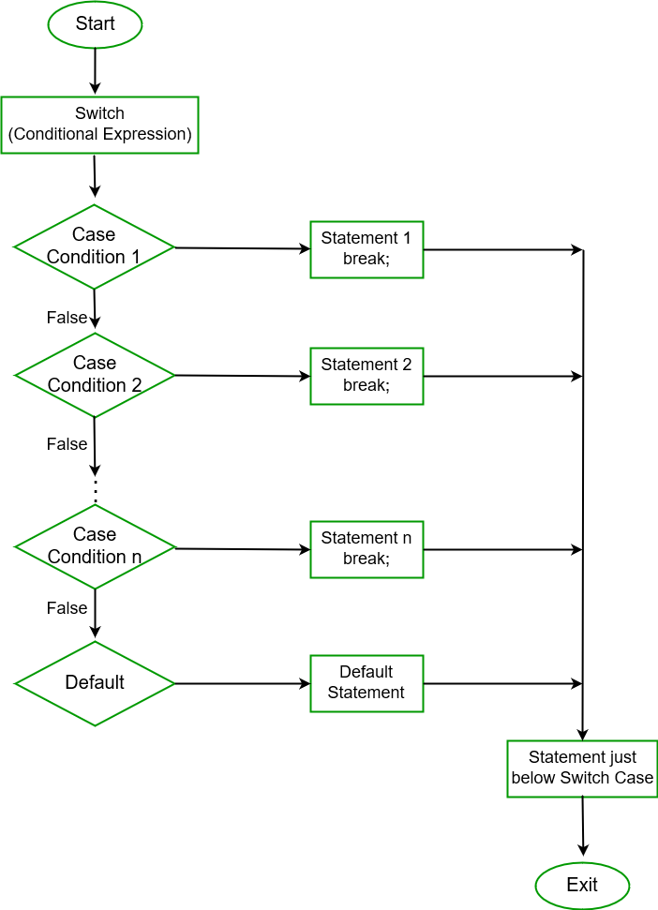

|  |  |
| --- | --- |
| **Syntax:** | **Code:** |
| **switch**(expression){  **case** value1:   //code to be executed;  **break**;  //optional  **case** value2:   //code to be executed;  **break**;  //optional  ......    **default**:  code to be executed **if** all cases are not matched;  } | **public** **static** **void** main(String[] args) {      //Declaring a variable for switch expression  **int** number=20;      //Switch expression  **switch**(number){      //Case statements  **case** 10: System.out.println("10");  **break**;  **case** 20: System.out.println("20");  **break**;  **case** 30: System.out.println("30");  **break**;      //Default case statement  **default**:System.out.println("Not in 10, 20 or 30");      }  } |

**Switch with String data example:**

public static void main(String[] args) {

    String color = "Green";

        switch (color) {

        case "Green":

            System.out.println("Go ahead - if clear!");

            break;

        case "Yellow":

            System.out.println("Yellow light - proceed with caution!");

            break;

        case "Red":

            System.out.println("Red light - Please STOP immediately!");

            break;

        default:

            System.out.println("Invaid color for traffic light - obey the officer!");

        }

    }

**Java loop statements:**

**1. for Loop:**

|  |  |
| --- | --- |
| **Syntax:** | **Code:** |
| **for(initialization;condition;incr/decr){**  **//statement or code to be executed**  **}** | **public** **static** **void** main(String[] args) {      //Code of Java for loop  **for**(**int** i=1;i<=10;i++){          System.out.println(i);         }  } |

**Char for loop:**

    public static void main(String[] args) {

            // to print the alphabet  a-z

        for (char c = 'a'; c <= 'z'; c++) {

            System.out.println(c);

        }

    }

**2. while Loop:**

|  |  |
| --- | --- |
| **Syntax:** | **Code:** |
| **while(condition){**  **//code to be executed**  **}** | **public** **static** **void** main(String[] args) {  **int** i=1;  **while**(i<=10){          System.out.println(i);      i++;      }  } |

**3. do while Loop:**

|  |  |
| --- | --- |
| **Syntax:** | **Code:** |
| **do{**  **//code to be executed**  **}while(condition);** | **public** **static** **void** main(String[] args) {  **int** i=1;  **do**{          System.out.println(i);      i++;      }**while**(i<=10);  } |

**4. for each Loop or Advanced for loop:**

|  |  |
| --- | --- |
| **Syntax:** | **Code:** |
| **for**(data_type item : collection) {      ...  } | **public** **static** **void** main(String[] args) {  **int**[] numbers = { 3, 4, 5, -5, 0, 12 };  **int** sum = 0;  **for** (**int** number : numbers) {              System.***out***.println(number);          }      } |

**Java break and continue statements:**

**break** statement:

* terminates loop and the program control resumes next statement after the loop.
* used to break loop or switch statement
* In case of inner loop, it breaks only inner loop.
* used in all types of loops such as **for** loop**, while** loop, **do-while** loop and **for each  (advanced for)** loop.

|  |  |
| --- | --- |
| **Syntax:** | **Code:** |
| **jump-statement;**  **break;** | **public** **static** **void** main(String[] args) {    **for**(**int** i=1;i<=10;i++){  //using for loop  **if**(i==5){              //breaking the loop  **break**;          }          System.out.println(i);      }  } |

**continue** statement:

* used in loop control structure when jump to the next iteration of the loop is needed immediately
* can be used with for loop or while loop.
* used to continue the loop. It continues the current flow of the program and skips the remaining code at the specified condition. In case of an inner loop, it continues the inner loop only.
* We can use Java continue statement in all types of loops such as for loop, while loop and do-while loop.

|  |  |
| --- | --- |
| **Syntax:** | **Code:** |
| **jump-statement;**  **continue;** | **public** **static** **void** main(String[] args) {  **for**(**int** i=1;i<=10;i++){  //using for loop  **if**(i==5){              //breaking the loop  **break**;          }          System.out.println(i);      }  } |